The Canonbury Society
CONSERVING CANONBURY
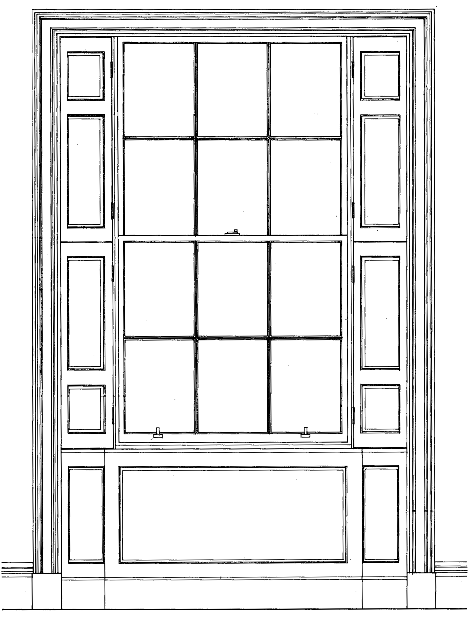

MEMBERSHIP APPLICATION FORM

Please complete and return this form to info@canonburysociety.org.uk so we can add you to the membership list. Or, send a paper copy to The Canonbury Society Membership Secretary, 32 Alwyne Road, London, N1 2HW.
Mobile:

Name (s):

Address:

Mobile:

Landline:

*Email:

* We do not send out many emails but we keep members updated on Canonbury news, and invite them to parties and events so please make sure you provide an email address.

Annual subscription
The minimum yearly subscription per household is £3, but larger amounts are gratefully received. You can pay by PayPal by clicking on the button on the Membership page. Or you can pay by BACS. Please make sure you clearly tag your payment with your name. Here are our bank details:

The Canonbury Society
Sort Code 30-94-57
Account Number 01350745

If you prefer to pay by cheque please make it payable to The Canonbury Society and send it to The Canonbury Society Treasurer, 3 Alwyne Road, London, N1 2HH.

We do not share the information we hold about you with any other organisations or companies and use our reasonable endeavours to keep it securely.

